LMS Project Report

There are 5 members for the Learning Management System project include:

Dzung Le

Alex Mendez

Thanh Ho

Kevin Nguyen

Yerusalem Tesfaldet

The Team model used for our team is the Chief Programmer model. We found that having the most experienced person leading the way and guiding the rest of the group to be the most efficient way. The rest supported our Chief programmer.

CRC Cards:

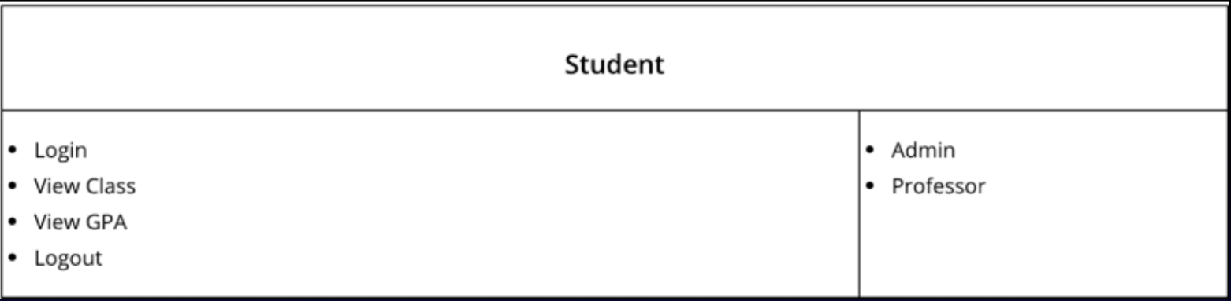

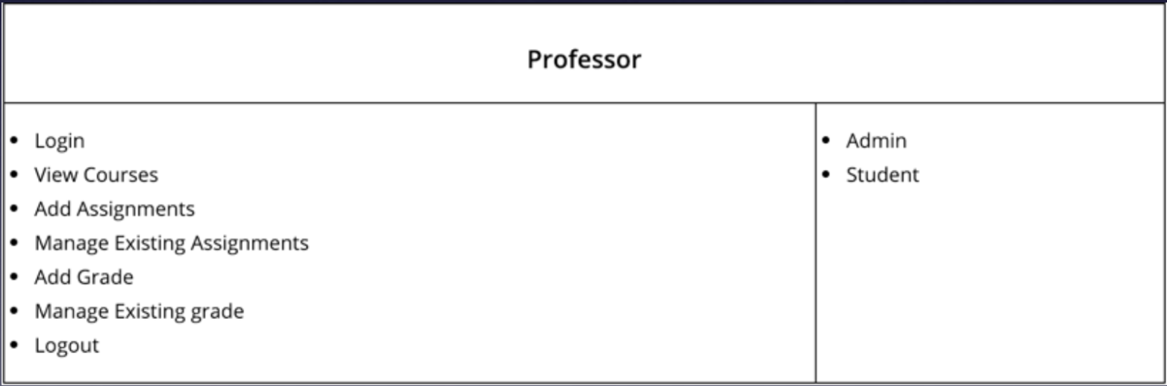

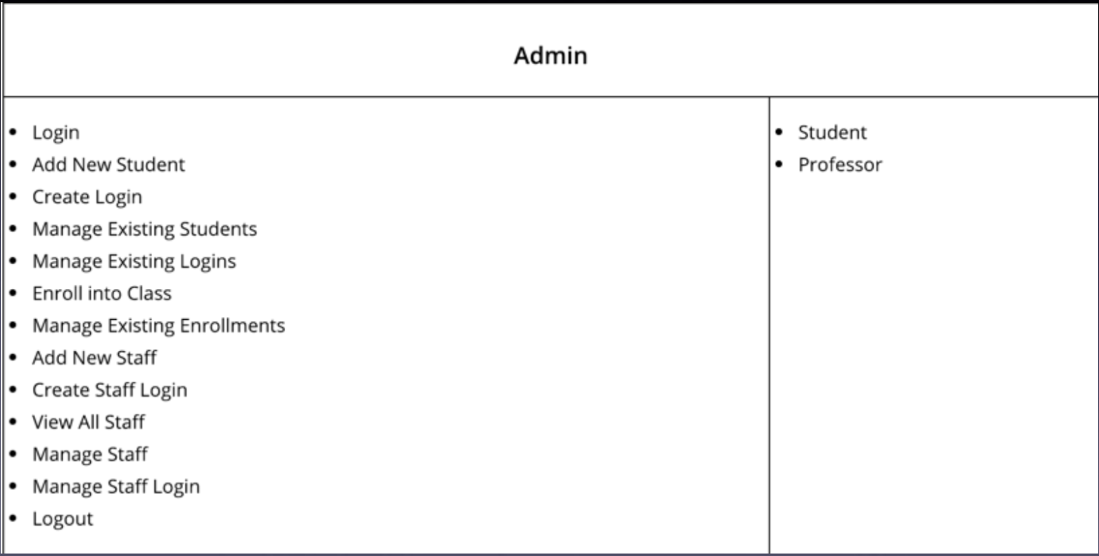

UML Diagram: 